SIMATS ENGINEERING (SAVEETHA SCHOOL OF ENGINEERING)

Department of Computer Science and Engineering

ASSESSMENT TOOL 1 – APPLICATION BASED QUESTIONS

Course Code: | CSA06 | Course Title: | Design and Analysis of Algorithms
CO Assessed: | CO1 – Precision (BL1, BL2, BL3) | Assessment: | Assessment Tool 1 – Application Based Questions
Weightage: | 40% of CIA | Total Marks: | 100
CO1 Statement: | Determine algorithm efficiency using asymptotic notations and mathematical techniques including Master Theorem and substitution method. (BL1, BL2, BL3)
Student Name: | Kishore Gadhi | Reg. No.: | 192365051
Section / Batch: | CSE(CYBER SECURITY) | Date:
Instructions to Students
- Answer the following question. It carries 100 Marks.
- Clearly show all steps in derivations and complexity analysis.
- Use proper asymptotic notation (Big-O, Big-Θ, Big-Ω) wherever required.
- Justify each step in recurrence solving using appropriate methods.
- Neat presentation and logical explanation are mandatory

Question Type | Focus Area | Questions
Application-Based Questions | Apply Master Theorem and asymptotic analysis to real-world scenarios | Q1

SECTION A – APPLICATION BASED QUESTIONS

Smart Grid Energy Distribution System
A smart grid system processes energy distribution data using the recurrence T(n) = 4T(n/2) + n log
n. Apply the Master Theorem to determine the time complexity. Clearly identify parameters and
justify the case selection. Analyze how the system scales with increasing network size. Interpret
the result using asymptotic notation.

Code of Conduct
I KISHORE GADHI (Name / Reg No) certify that this submission is my original work and that I have adhered to the guidelines specified for this assessment. I understand that any violation of academic integrity rules will result in disciplinary action.
Signature of the Student: G.Kishore .

RUBRICS FOR CALCULATION

Criteria | Wt. | Level 4 – Exemplary | Level 3 – Proficient | Level 2 – Developing | Level 1 – Beginning
Understanding of Problem Context | 20% | Clearly understands the problem and accurately identifies all requirements | Good understanding with minor gaps | Basic understanding; some requirements unclear | Poor understanding or misinterpretation of the problem
Application of Concepts | 30% | Accurately applies appropriate concepts to solve complex problems | Applies relevant concepts correctly with minor errors | Applies basic concepts with limited accuracy | Fails to apply appropriate concepts
Problem-Solving Approach | 20% | Logical, well-structured, and efficient approach | Mostly logical approach with minor gaps | Basic approach with some inconsistencies | Illogical or unclear approach
Accuracy of Solution | 20% | Completely correct solution with proper justification | Mostly correct with minor errors | Partially correct solution | Incorrect or incomplete solution
Clarity | 10% | Clear, well-organized, and properly explained solution | Understandable with minor clarity issues | Limited clarity and explanation | Poorly presented and difficult to understand

Marks Evaluation:
Criteria | Wt. | Level 4 – Exemplary | Level 3 – Proficient | Level 2 – Developing | Level 1 – Beginning
Understanding of Problem Context | 20%
Application of Concepts | 30%
Problem-Solving Approach | 20%
Accuracy of Solution | 20%
Clarity | 10%
Total Marks (100):

Faculty In-charge | Course Coordinator | Head of Department
Name: | Name: | Name:
Signature: | Signature: | Signature:
Date: | Date: | Date:

Execution & Output :

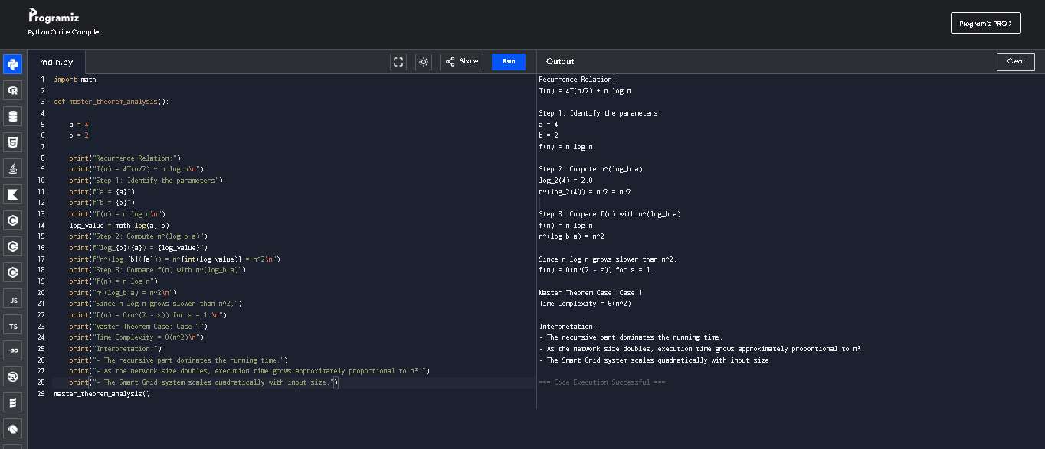

PROGRAM:
import math

def master_theorem_analysis():
# Given recurrence: T(n) = 4T(n/2) + n log n

a = 4
b = 2

print("Recurrence Relation:")
print("T(n) = 4T(n/2) + n log n\n")

print("Step 1: Identify the parameters")
print(f"a = {a}")
print(f"b = {b}")
print("f(n) = n log n\n")

# Calculate log_b(a)
log_value = math.log(a, b)

print("Step 2: Compute n^(log_b a)")
print(f"log_{b}({a}) = {log_value}")
print(f"n^(log_{b}({a})) = n^{int(log_value)} = n^2\n")

print("Step 3: Compare f(n) with n^(log_b a)")
print("f(n) = n log n")
print("n^(log_b a) = n^2\n")

print("Since n log n grows slower than n^2,")
print("f(n) = O(n^(2 - ε)) for ε = 1.\n")

print("Master Theorem Case: Case 1")
print("Time Complexity = Θ(n^2)\n")

print("Interpretation:")
print("- The recursive part dominates the running time.")
print("- As the network size doubles, execution time grows approximately proportional to n².")
print("- The Smart Grid system scales quadratically with input size.")

master_theorem_analysis()

OUTPUT:

Recurrence Relation:
T(n) = 4T(n/2) + n log n

Step 1: Identify the parameters
a = 4
b = 2
f(n) = n log n

Step 2: Compute n^(log_b a)
log_2(4) = 2.0
n^(log_2(4)) = n^2 = n^2

Step 3: Compare f(n) with n^(log_b a)
f(n) = n log n
n^(log_b a) = n^2

Since n log n grows slower than n^2,
f(n) = O(n^(2 - ε)) for ε = 1.

Master Theorem Case: Case 1
Time Complexity = Θ(n^2)

Interpretation:
- The recursive part dominates the running time.
- As the network size doubles, execution time grows approximately proportional to n².
- The Smart Grid system scales quadratically with input size.

